adminController

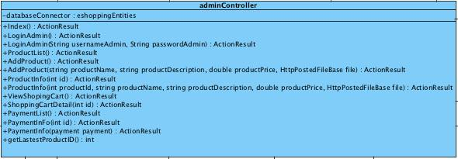

Attribute

|  |  |  |  |
| --- | --- | --- | --- |
| No. | Name | Description | Type |
| MDA.1-1 | databaseConnector | Object connect to the data base | eshoppingEntities |

Methods

|  |  |  |  |  |
| --- | --- | --- | --- | --- |
| No. | Name | Parameters | Description | Return |
| MDM.1-1 | Index | None | Return to Index.cshtml | ActionResult |
| MDM 1-2 | LoginAdmin | None | Return to LoginAdmin.cshtml | ActionResult |
| MDM.1-3 | LoginAdmin | string, string | This method is use for Administrator validation of the authentication system | ActionResult |
| MDM 1-4 | ProductList | None | This method is use for return the ProductList.cshtml for display the list of all product in the system. | ActionResult |
| MDM.1-5 | AddProduct | None | This method is use for return to view AddProduct.cshtml | ActionResult |
| MDM.1-6 | AddProduct | string, string, double, HttpPostedFileBase | The method is use for add the product information which is Product Name, Product Description, Product Price and Product Picture into the system. | ActionResult |
| MDM.1-7 | ProductInfo | int | The method is use for view the detail of the product by each identifier. | ActionResult |
| MDM.1-8 | ProductInfo | int, string, string, double, HttpPostedFileBase | The method is use for update the detail of the product by each identifier. | ActionResult |
| MDM.1-9 | ViewShoppingCart | None | The method is use for vewing the Shopping History of all Customer | ActionResult |
| 1 MDM.1-10 | ShoppingCartDetail | int | The method is use for view the detail of the ShoppingCart by each identifier. | ActionResult |
| MDM.1-11 | PaymentList | None | The method is use for view the overall detail of the Payment History | ActionResult |
| MDM.1-12 | PaymentInfo | int | This method is for view the specific detail of Payment History by its identifier | ActionResult |
| MDM.1-13 | PaymentInfo | payment | This method is for edit the specific detail of Payment History by its identifier | ActionResult |
| MDM.1-14 | getLastestProductID | None | This method is used for rename the picture file according to the identifer of the product that it supposed to be when the product has been added to Administrator. | Integer |

homeController

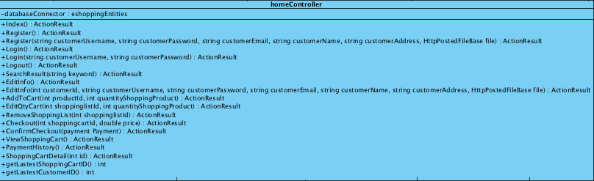

Attribute

|  |  |  |  |
| --- | --- | --- | --- |
| No. | Name | Description | Type |
| MDA.1-2 | databaseConnector | Object connect to the data base | eshoppingEntities |

Methods

|  |  |  |  |  |
| --- | --- | --- | --- | --- |
| No. | Name | Parameters | Description | Return |
| MDM.2-1 | Index | None | Return to Index.cshtml | ActionResult |
| MDM.2-2 | Register | None | Return to Register.cshtml | ActionResult |
| MDM.2-3 | Register | string, string, string, string, string, HttpPostedFileBase | The method use for registering the Customer into the system. | ActionResult |
| MDM.2-4 | Login | None | Return to Login.cshtml | ActionResult |
| MDM.2-5 | Login | string, string | This method is use for Customer information validation of the authentication system. | ActionResult |
| MDM.2-6 | Logout | None | Return to Index.cshtml | ActionResult |
| MDM.2-7 | SearchResult | string | The method use for display the search result of the product from Customer keyword for Customer. | ActionResult |
| MDM.2-8 | EditInfo | None | Return Edit.cshtml | ActionResult |
| MDM.2-9 | EditInfo | int, string, string, string, string, string, HttpPostedFileBase | The method use for support the edited Customer infromation from Customer. | ActionResult |
| MDM.2-10 | AddToCart | int, int | The method for add the Product into shopping list in the shopping cart. | ActionResult |
| MDM.2-11 | EditQtyCart | int, int | The method for update the quantity of each shopping list in the shopping cart. | ActionResult |
| MDM.2-12 | RemoveShoppingList | int | The method for remove each shopping list in the shopping cart. | ActionResult |
| MDM.2-13 | Checkout | int, doble | This method is use for the customer request the Shopping cart check out to the system. After the customer view the shopping cart summary. | ActionResult |
| MDM.2-14 | ConfirmCheckout | payment | The method for creating the payment detail into the system | ActionResult |
| MDM.2-15 | ViewShoppingCart | None | Return to view shoppingcart.cshtml for View the list of his/her own Shopping History | ActionResult |
| MDM.2-16 | PaymentHistory | None | Return to PaymentHistory.cshtml | ActionResult |
| MDM.2-17 | ShoppingCartDetail | int | Return to ShoppingCartDetail.cshtml | ActionResult |
| MDM.2-18 | getLastestShoppingCartID | None | The method is used for get the lastest shopping cart according to the identifier of the customer for add to cart prooces | int |
| MDM.2-19 | getLastestCustomerID | None | This method is used for rename the picture file according to the identifer of the customer that it supposed to be when the customer has been registered | int |

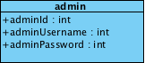Admin

Attribute

|  |  |  |  |
| --- | --- | --- | --- |
| No. | Name | Description | Type |
| MDA.2-1 | adminId | Unqiue Identifier of Administrator | int |
| MDA.2-2 | adminUsername | Username of Administrator | int |
| MDA.2-3 | adminPassword | Password of Administrator | int |

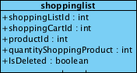shoppinglist

|  |  |  |  |
| --- | --- | --- | --- |
| No. | Name | Description | Type |
| MDA.3-1 | shoppingListId | Unqiue Identifier of Shopping List | int |
| MDA.3-2 | shoppingCartId | Unqiue Identifier of Shopping Cart | int |
| MDA.3-3 | productId | Unqiue Identifier of Product | int |
| MDA.3-4 | quantityShoppingProduct | Quantity of Shopping Product | int |
| MDA.3-5 | isDeleted | Status to check whether the Shoppinglist is deleted or not | boolean |

payment

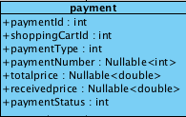

|  |  |  |  |
| --- | --- | --- | --- |
| No. | Name | Description | Type |
| MDA.4-1 | paymentId | Unique Identifier of Payment | int |
| MDA.4-2 | shoppingCartId | Unqiue Identifier of Shopping Cart | int |
| MDA.4-3 | paymentType | Type of Payment | int |
| MDA.4-4 | paymentNumber | Transaction Number for each Payment Type | Nullable<int> |
| MDA.4-5 | totalprice | Total Amount that Customer has to pay | Nullable<double> |
| MDA.4-6 | receivedprice | Received Amount that Customer paid | Nullable<double> |
| MDA.4-7 | paymentStatus | The status of Payment | int |

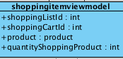shoppingitemviewmodel

|  |  |  |  |
| --- | --- | --- | --- |
| No | Name | Description | Type |
| MDA.5-1 | shoppingListId | Unqiue Identifier of Shopping List | int |
| MDA.5-2 | shoppingCartId | Unqiue Identifier of Shopping Cart | int |
| MDA.5-3 | product | Model entity of Product | product |
| MDA.5-4 | quantityShoppingProduct | Quantity of each ordered Product | int |

product

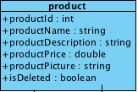

|  |  |  |  |
| --- | --- | --- | --- |
| No | Name | Description | Type |
| MDA.6-1 | productId | Unqiue Identifier of Product | int |
| MDA.6-2 | productName | Name of the Product | string |
| MDA.6-3 | productDescription | Description of the Product | string |
| MDA.6-4 | productPrice | Price of the Product | double |
| MDA.6-5 | productPicture | Picture of the Product | string |
| MDA.6-6 | isDelete | Status to check whether the Product is deleted or not | boolean |

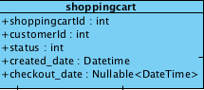shoppingcart

|  |  |  |  |
| --- | --- | --- | --- |
| No | Name | Description | Type |
| MDA.7-1 | shoppingCartId | Unqiue Identifier of Shopping Cart | int |
| MDA.7-2 | customerId | Unqiue Identifier of Customer | int |
| MDA.7-3 | status | Shopping Cart status | int |
| MDA.7-4 | created_date | Date & Time that the Shopping has been created | Datetime |
| MDA.7-5 | checkout_date | Date & Time that the Shopping has been checked out | Nullable<DateTime> |

paymenthistory

MACINTOUSH:Users:Parn:Downloads:รูปclass diagram แยก:Screen Shot 2557-02-10 at 4.39.31 PM.png

|  |  |  |  |
| --- | --- | --- | --- |
| No | Name | Description | Type |
| MDA.8-1 | shoppingcart | Model entity of ShoppingCart | shoppingcart |
| MDA.8-2 | payment | Model entity of Payment | payment |

checkoutviewmodel

MACINTOUSH:Users:Parn:Downloads:รูปclass diagram แยก:Screen Shot 2557-02-10 at 4.39.43 PM.png

|  |  |  |  |
| --- | --- | --- | --- |
| No | Name | Description | Type |
| MDA.9-1 | shoppingitem | The list of View Model shoppingitemviewmodel | List <shoppingitemviewmodel> |
| MDA.9-2 | payment | Model entity of Payment | payment |

Customer

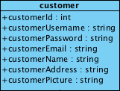

|  |  |  |  |
| --- | --- | --- | --- |
| No | Name | Description | Type |
| MDA.10-1 | customerId | Unique Identifier of Customer | int |
| MDA.10-2 | customerUsername | Username of Customer | string |
| MDA.10-3 | customerPassword | Password of customer | string |
| MDA.10-4 | customerEmail | Email of Customer | string |
| MDA.10-5 | customerName | Name of Customer | string |
| MDA.10-6 | customerAddress | Address of Customer | string |
| MDA.10-7 | customerPicture | Picture of Customer | string |